DP-internal Structure and Agreement in Nafara

Senufo Nafara DPs show the particularly rare unmarked word order [N AP Def Dem Numeral]. In this cartographic account, the proposed derivation uses spec-to-spec movement operations to generate this word order (Cinque 2005). This analysis relies on two main claims: there is a domain ƩP under Num (Aboh 2004) in which two distinct categories of adjectives (high and low following Cinque 1994) merge to modify the noun. It is this same ƩP domain that undergoes spec-to-spec movement, motivated for agreement purposes. Oppositely, all elements structurally above ƩP remain in situ.

1. Introduction

Nafara is a Senufo language[1] spoken in Korhogo, Côte d’Ivoire. Determiner phrases in the language show the canonical word order [N Adj D Dem Num], like in (1) below.[2]

1. lo tã -gə̄l gal kɔrʃi  
   mango sweet -def.3.pl dem.3.pl seven  
   N Adj -D Dem Num  
   *‘these seven sweet mangoes’[3]*

As we see here, attributive adjectives usually directly follow the noun. While they do not seem to show agreement, adjectives are apparently the host for the number and gender specific determiner. [4] The demonstrative directly follows the determiner, and inflects for number and gender also. Numerals are DP-final in the language, and do not show concord.[5]

The DP word order in (1) is highly unexpected, as argued by Cinque (2005). First, cross-linguistically, Numerals in DP-final position are noticeably rare. Then, syntactically speaking, the derivation of this word order is usually considered marked (Cinque, 2005).

This paper accounts for both the syntactic structure and derivation of Nafara DPs, assuming the universal functional hierarchy [ Dem > Num > Adj > N ] adopted by Greenberg (1963), Cinque (2005) and others. In 2.1, I first discuss the location of each DP-internal element. I also draw distinctions between two separate categories of adjectives (that I refer to as high and low, corresponding to Cinque’s 2010 indirect and direct modification respectively). In 2.2, I motivate the movement of adjectives and noun only, responsible for the surface word order. Finally, in 2.3, I show that such movement is motivated for agreement purposes.

1. DP structure and word order
   1. Assumptions and data
      1. The functional structure of DPs

In a cartographic approach to DP structure, Greenberg (1963) and Cinque (2005) argue that the only possible initial order capable of universally generating the DP word orders attested in natural language is [ Dem > Num > Adj > N ]. Assuming the underlying structure in Figure 1, Cinque accounts for all possible word orders as the result of some type of movement of NP. Namely, he argues for combinations of successive Spec-to-Spec movements with or without pied-piping of NP up the DP spine.

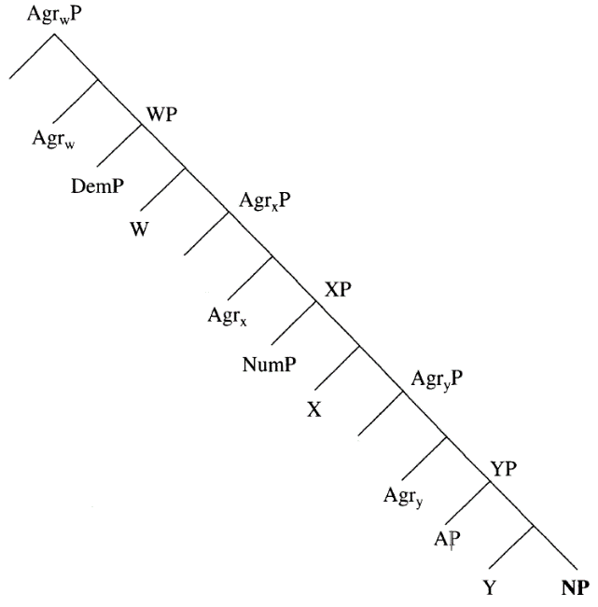

Figure 1: the cartographic representation of DPs (adapted from Cinque 2005: (2)).

Note here that, in Cinque’s account, Num, Dem, and A are heads of their own functional projections (henceforth FPs) above NP. Those FPs merge in the Specifier of phrases (here WP, XP, and YP) that are all sisters to an Agree node, head of an AgrP where NP potentially lands when undergoing movement. From a Minimalist perspective (Chomsky 1995), such a structure violates the economy principle by assuming that additional and potentially unnecessary elements merge into the syntactic structure. Therefore, and in an effort to preserve Cinque’s hierarchy, I assume the syntactic structure in (2) below, where functional elements all merge directly above NP and below D as heads of their own projections, and where AgrPs are eliminated.[6] Adjectives are not included in (2). Their location and behavior will be discussed more thoroughly in 2.1.5.

1. [DP … D [DemP … Dem [NumP … Num [NP … N ]]]]

The remainder of 2.1 will focus on the distribution and properties characteristic of each functional and lexical category represented in Nafara DPs.

* + 1. Determiners

Nafara determiners agree in gender and number with the noun they determine. They obligatorily attach to the right edge of the noun in simple DPs, as in (3). However, in the presence of AP, they attach to the AP final element, as in (4). It is important to note here the variable placement of the adverb in the AP.



a. lo**-gə̄l**

mango **-def.3.pl**

*‘the mangoes’*

b.\***gə̄l**  lo

**def.3.pl** mango

*‘the mangoes’*

1. lo [(dɛl) tã / tã (tɛl) ] -gə̄l

mango [(very) sweet / sweet (very) ] -DEF.3.PL

‘the very sweet mangoes’

Cinque (2005) does not account for determiners and how or where they surface in the DP. Because they are separate morphemes in Nafara, and because it is the only DP-internal element encoding definiteness, I take the definite marker to be the realization of the D head, merging as the sister to the highest DP-internal functional projection, as in (2) above. That D head is spelled out *in situ*, cliticizing to the final extended noun phrase element located in its specifier, as shown in 2.2.

* + 1. Demonstratives

Demonstratives also inflect for number and gender. They necessarily follow the determiner, as shown in (5).

a. pɔm tã -bɛl **bal**

apple sweet -def.1.pl **dem.1.pl**

*‘these sweet apples’*

b.* pɔm **bal** tã -bɛl

apple **dem.1.pl** sweet -def.1.pl

*‘these sweet apples’*

Following Cinque’s (2005) account, I assume that they merge rather high in DP, as the head of a functional projection DemP.

* + 1. Numerals

As shown below, numerals occur in DP-final position. Because the literature on numerals has not led to any consensus on their syntax, both cross-linguistically and within languages, and due to the fact that I have no further evidence to motivate a more elaborate account for the distribution and properties of numerals in Nafara, I follow Cinque (2005) in assuming that they merge as the head of a functional projection NumP.[7]

1. *‘one’*

a. pɔm -u **nuã**

apple -def.1.sg **one.1**

*‘the one apple’*

b. ʧi -g **nuŋgɔ**

tree -def.2.sg **one.2**

*‘the one tree’*

c. lo -n **nunã**

mango -def.3.sg **one.3**

*‘the one mango’*

1. *‘seven’*

a. pɔm -u **kɔrʃi**

apple -def.1.pl **seven**

*‘the seven apples’*

b. ʧi -i **kɔrʃi**

tree -def.2.pl **seven**

*‘the seven trees’*

c. lo -gel **kɔrʃi**

mango -def.3.pl **seven**

*‘the seven mangoes’*

Note here that while ‘seven’ in (7) – as well as any other number in the language – does not inflect for gender, the number ‘one’ in (6) along with all numbers compounded with ‘one’ do. For this reason, I argue that ‘one’ merges in Num with an unvalued gender feature [ugen]. Following both Greenberg (1963) and Cinque (2005), I assume NumP to be below DemP in the functional projection hierarchy. The DP word order in Nafara is [N A D Dem Num] as in (1), repeated in (8) below.

1. lo tã -gə̄l gal kɔrʃi  
   mango sweet -def.3.pl dem.3.pl seven  
   N Adj -D Dem Num  
   *‘these seven sweet mangoes’*
   * 1. Adjectives

So far, I have argued that attributive adjectives directly follow the noun they modify, as in (9)a below. The ungrammaticality of (9)b and (9)c shows that attributive adjectives that occur in postnominal position (that is to say most adjectives in the language) cannot occur in prenominal position.



a. lo**tã** -gə̄l mango **sweet**  -def.3.pl   
 *‘the sweet mangoes’*

b.* **tã** lo-gə̄l **sweet**  mango -def.3.pl   
 *‘the sweet mangoes’*

c.* **tã** -gə̄l lo  
 **sweet**  -def.3.pl mango   
 *‘the sweet mangoes’*

There are however certain adjectives that can only occur prenominally. It is the case for adjectives of nationality, as shown in (10)a.

a. **kodivware** ʃju -u   
 **Ivorian**  man -def.3.sg  
 *‘the Ivorian man’*

b. * ʃju -u **kodivware**   
 man -def.1.sg **Ivorian** *‘the Ivorian man’*

c. * ʃju **kodivware** -u man  **Ivorian** -def.1.sg  
 *‘the Ivorian man’*

d. * **kodivware** -u ʃju   
 **Ivorian** -def.1.sg man   
 *‘the Ivorian man’*

In (10)b and (10)c, we see that the same adjective cannot occur after the noun, either preceding or following the determiner. This does not result in a semantic alteration of the DP, but in complete ungrammaticality. (10)d shows that such adjectives cannot be the host for the determiner clitic.

Cinque (1994) argues that adjective phrases merge in the Specifier position of functional projections occurring in a fixed order above NP based on a strict hierarchy, as in (11).

1. [FP  AP F [ AP F [ AP F [NP  N ] ] ] ]

The data above is somewhat surprising, as it contradicts the semantic hierarchy for adjectives proposed by Cinque (1994) according to which adjectives of nationality merge lower than adjectives of quality (Cinque 1994: 96). One major difference here is that Nafara postnominal adjectives are ordered freely, as in (12) below. Therefore, as is, the data does not allow us to posit any specific ranking of adjectives of nationality relatively to other types of adjectives.

a. pɔm tã ʧɛ̃ ɲe -bɛl apple sweet good red -def.1.pl  
 *‘the sweet good red apples’*

b. pɔm ʧɛ̃ tã ɲe -bɛl apple good sweet red -def.1.pl  
 *‘the sweet good red apples’*

c. pɔm ʧɛ̃ ɲe tã -bɛl apple good red sweet -def.1.pl  
 *‘the sweet good red apples’*

d. pɔm ɲe tã ʧɛ̃ -bɛl apple red sweet good -def.1.pl  
 *‘the sweet good red apples’*

Due to the fact that both pre- and postnominal adjectives exist in Nafara, and because postominal adjectives can be ordered freely, I follow Cinque (2010) in differentiating between two types of adjectives merging in two distinct positions in the syntax. While postnominal (low) adjectives merge as adjuncts inside NP (which explains their free ordering), prenominal (high) adjectives merge higher in the structure. Following Cinque, the latter are in fact reduced relative clauses (henceforth RC) merging in the Specifier of a projection above NP.

Applying this analysis to Nafara, I propose the syntactic representation in (13) below, where the few semantically selected reduced RC adjectives in the language merge in the specifier of the extended nominal domain that I call ƩP following Aboh (2004).[8]

1. [DP … D [DemP … Dem [NumP … Num [ƩP [AhighP] ∑ [NP … [NP N] [AlowP] ] ] ] ] ]

Considering the word order [ Ahigh N Alow  D Dem Num ] in (14), I argue that high and low adjectives all remain in situ within ƩP during the entire derivation.[9]

1. kodivware lo ʧɛ̃ tã -gə̄l gal kɔrʃi  
    Ivorian mango good sweet -def.3.pl dem.3.pl seven  
    Ahigh N Alow Alow -D Dem Num  
     *‘these seven good sweet Ivorian mangoes’*

In the following section, I show that only ƩP moves up the DP spine, generating the surface word order. I will illustrate this derivation, and motivate it in Section 3.

* 1. Underlying structure and derivation

In his DP typology, Cinque (2005) argues that all attested word orders are the result of NP undergoing some type or combination of movements. According to him, total roll-up movement (also referred to as Spec-to-Spec movement with pied-piping) is the least marked type of movement available. Regarding the word order [ N A Dem Num ] (which is the one we observe here in Nafara DPs), Cinque argues that it is rather rare, but derived as in (15).

1. **(N A Dem Num[eral])** has a derivation in which NP raises past A, followed by pied-piping of the *whose picture* type past Num[eral], followed by raising of [N A] without pied-piping (**marked**) past Dem. (Cinque 2005: 323(6l))

Cinque argues that what makes this word order rather uncommon is that it is somewhat marked. NP undergoes a combination of roll-up and Spec-to-Spec movement, as shown in Figure 2, adapted from Cinque (2005).

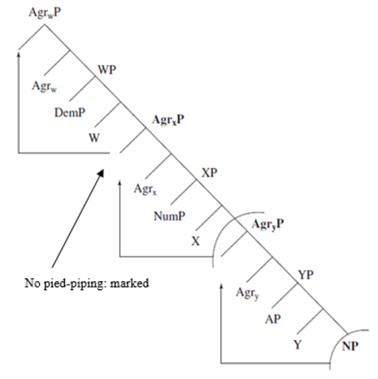

Figure 2: syntactic derivation for the word order N A Dem Num (adapted from Cinque 2005).

In 2.1.5, I have established that low adjectives are adjuncts inside NP, and high adjectives merge in Spec,ƩP, an extended nominal projection. Therefore, NP no longer needs to raise past AP and then raise along with AP past Num. Instead, the entire ƩP, including the high and low attributive adjectives, moves up. Figure 3 is a tree representation of the phrase in (16) where this movement is illustrated.

1. kodivware lo dɛl tã -gə̄l gal kɔrʃi  
    Ivorian mango very sweet -def.3.pl dem.3.pl seven   
    *‘these seven very sweet Ivorian mangoes’*

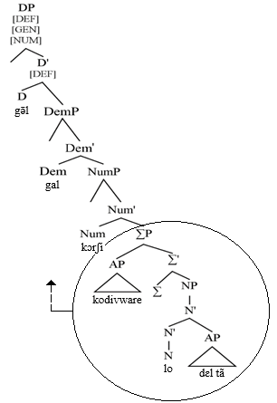

Figure 3: Feature Percolation in Nafara DPs.

The syntactic structure in Figure 3 clearly shows that, to obtain the desired word order [ Ahigh N Alow D Dem Num ], ƩP must move up without pied-piping and eventually reach Spec,DP (to precede D, Dem, and Num in that order). Therefore, and contra Cinque in (15) and Figure 2, I argue that ƩP undergoes a uniform Spec-to-Spec movement without pied-piping all the way up. However, this movement must be correctly motivated.

In 2.3, I demonstrate that movement is triggered by syntactic agreement with N. Due to some agreement effects that I will explain, ƩP is the phrase that gets selected, and raises to Spec,DP by way of Spec-to-Spec movement.

* 1. Agree and DP word order
     1. Agree

As previously mentioned, number and gender are active features of Nafara nominal concord. The phrase in (1), repeated here in (17), shows that both the determiner and the demonstrative agree in number and gender.

1. lo tã -gə̄l gal kɔrʃi  
    mango sweet -def.3.pl dem.3.pl seven  
     *‘these seven sweet mangoes’*

Debatably, nominal concord has been argued to be the result of an operation called Agree (Chomsky 2000; 2001), also considered responsible for subject-verb agreement (Baker 2008; Carstens 2001; Collins 2004, among others). One version of the operation is provided in (18).

1. **Agree** (Norris 2014: (26))

A probe X establishes an Agree relation with a goal YP, where:   
a. X c-commands YP,  
b. X lacks values for uninterpretable features that can be supplied by the values of matching features on Y,   
c. Y lacks values for uninterpretable features that can be supplied by X,   
d. No potential goal intervenes between X and Y,   
e. X and Y are in the same phase.   
Agree supplies the values of each category’s uninterpretable features from matching features of the other category, with the two features coalescing into a single shared feature.

Let us now see how this operation can account for DP-internal agreement and word order in Nafara.

* + 1. Agree, EPP, and ƩP movement

I argue here that D merges with a set of features that contains at least one valued feature – definiteness [DEF], and two unvalued features – number [NUM] and gender [GEN]. Additionally, D merges with an EPP feature. Similarly, Dem merges with unvalued [NUM] and [GEN] features, and the numeral arguably merges as the head of NumP with a gender feature that is unvalued (that is at least the case for ‘one’, overtly inflecting for gender as shown in (6)).

By way of Agree, all these functional elements look down their c-command domain for the missing values. As N comes from the lexicon with both [NUM] and [GEN], it is the best possible goal for all of them to probe down to.

While N is the best potential goal, it is ƩP that moves up. In fact, the same Agree relation through which DP-internal functional elements probe down to N selects ƩP to move up to Spec,DP. In his account for Estonian concord, Norris (2014) argues that the DP-internal agreement pattern observed in the language is made possible by a syntactic principle called Feature Percolation, presented here in (19).

1. **Feature Percolation**  (Norris 2014: 135 (242))

a. All projections of a head X0 have the feature-value pairs that X0 has.   
 b. Let [F:val] be a valued feature on XP.  
 Let Z0 be a head lacking the feature [F].  
 Let X0 and Z0 be members of the same extended projection (i.e., both [+N]).  
 When Z0 merges with XP, projecting ZP, ZP also has the valued feature [F:val].

According to (19), as heads merge into the structure with valued features, those same features percolate to the phrase those heads project. In Figure 4, I show how this principle applies in the Nafara DP. By way of Feature Percolation, and due to the fact that ƩP is nominal, I argue that the features [gen] and [num] percolate all the way up to ƩP.

Since agreement with N occurs all the way up the DP spine, I argue that ƩP undergoes Spec-to-Spec movement up to Spec,DP where the EPP feature on D is satisfied.

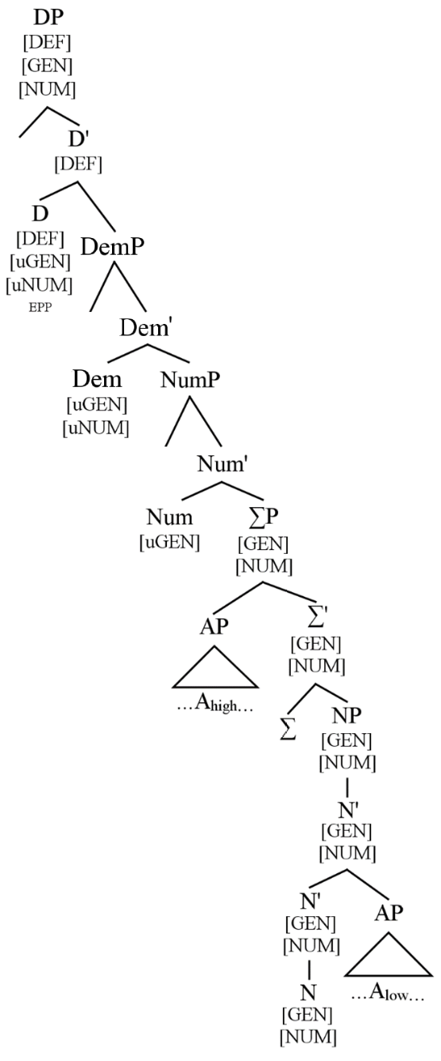

Figure 4: Feature Percolation in Nafara DPs.

1. Conclusions

In this paper, I have accounted for the structure and word order occurring in Nafara DPs. Following Cinque (2005), I argue for D > Dem > Num > A > N to be the DP-internal hierarchy. Additionally, and following Cinque (2010), I argue that there are two distinct types of attributive adjectives, that I refer to as high and low, and that do not seem to be interchangeable in the language. Finally, I argue that the surface word order is derived by moving ƩP to Spec,DP, for agreement purposes and due to the presence of an EPP feature on D. Because it is structurally higher than ƩP, Num does not undergo movement. For this reason, it surfaces in DP final position. The Spec-to-Spec movement of ƩP is illustrated in (20) below.

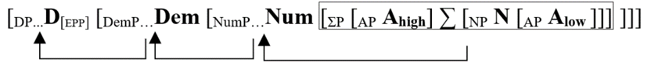

Aboh, Enoch. 2004. *The Morphosyntax of Complement-Head Sequences.* Oxford: Oxford University Press.

Baker, Mark. 2003. *The Lexical Categories: Verbs, Nouns, and Adjectives.* Cambridge: Cambridge University Press.

Baker, Mark. 2008. *The Syntax of Agreement and Concord.* Cambridge: Cambridge University Press.

Bendor-Samuel, John. 1971. Niger–Congo: Gur. In: Thomas Sebeok & Jack Berry (eds.), *Linguistics in sub-saharan Africa (Current trends in linguistics 7).* The Hauge/Paris: Mouton. 141–178.Bendor-Samuel 1971

Carstens, Vicki. 2001. Multiple agreement and Case deletion. *Syntax* 4.3: 147-163.

Carstens, Vicki. 2005. Agree and EPP in Bantu. *Natural Language and Linguistic Theory* 23: 219-279

Chomsky, Noam. 1995. *The Minimalist Program.* Cambridge: MIT Press.

Chomsky, Noam. 2000. Minimalist inquiries: the framework. In Roger Martin, David Michaels & Juan Uriagereka (eds.), *Step by step: Essays on minimalism in honor of Howard Lasnik*, 89–156. Cambridge: MIT Press.

Chomsky, Noam. 2001. Derivation by Phase. In Michael Kenstowicz (ed.), *Ken Hale: A Life in Language*, 1–52. Cambridge: MIT Press.

Cinque, Guglielmo. 1994. On the evidence for partial N movement in the Romance DP. In *Paths toward Universal Grammar*, ed. by Guglielmo Cinque, Jan Koster, Jean- Yves Pollock, Luigi Rizzi, and Raffaella Zanuttini, 85-110. Washington, DC: Georgetown University Press.

Cinque, Guglielmo. 2005. Deriving Greenberg’s Universal 20 and its exceptions. *Linguistic Inquiry* 36. 315–332.

Cinque, Guglielmo. 2010. *The Syntax of Adjectives.* Cambridge: MIT Press.

Collins, Chris. 2004. The agreement parameter. In Anne Breitbarth and Henk van Riemsdijk, eds. *Triggers.* 115-136. New York: Mouton.

Danon, Gabi. 2012. Two structures for numeral-noun constructions. *Lingua* 122. 1282–1307

Greenberg, Joseph. 1963. Some universals of grammar with particular reference to the order of meaningful elements. In Joseph Greenberg (ed.), *Universals of language.* 73–113. Cambridge, Mass.: MIT Press.

Ionin, Tania, Matushansky, Ora. 2006. The composition of complex cardinals. *Journal of Semantics* 23. 315–360.

Manessy, Gabriel. 1975. *Les langues Oti-Volta*. Paris: SELAF.

Naden, Anthony. 1989. Gur. In John Bendor-Samuel and Rhonda Hartell (eds.), *The Niger-Congo languages. A classification and description of Africa’s largest language family*. Lanham, New York, London : University Press of America. 140–168.

Norris, Mark. 2014. *A Theory of Nominal Concord*. UC Santa Cruz. PhD Dissertation.

Westermann, Diedrich & Bryan, M.A. (1970 [1952]). *The Languages of West Africa*. Oxford: International African Institute / Oxford University Press.

1. Although there is some controversy over its classification (Manessy 1975, Naden 1989), Senufo is traditionally defined as a branch of the Niger-Congo, Gur subgroup (Westermann 1970, Bendor-Samuel 1971).
2. Glossing and abbreviations are as follows: A(dj) - adjective, 1 - gender1, 2 - gender2, 3 - gender3, D - determiner, DEF - definite, Dem - demonstrative, INDEF - indefinite, Num - numeral, PL - plural, SG - singular.
3. The data introduced and analyzed throughout this paper was elicited from a native speaker of Senufo Nafara.
4. The noun classification adopted in this paper is adapted from those provided by both Manessy (1996:22) and Carlson (1994:76) for other Senufo varieties. Nafara shows a 5-gender system, where genders 1, 2, and 3 consist of countable nouns, and genders 4 and 5 are for non-count nouns. Considering the scope of this paper, I will limit my discussion to countable nouns.
5. This is true of all numerals except ‘one’ which shows gender agreement, as shown in 2.1.4.
6. The present analysis for the surface DP word order in Nafara does not justify the need for AgrPs to be generated in the syntax.
7. Cross-linguistically, numerals have either been analyzed as lexical or functional categories, showing great cross-linguistic differences (Danon 2012, Ionin & Matushansky 2006, among others).
8. In his account for Gungbe – and ultimately for Gbe languages, Aboh (2004) argues in favor of an extended noun phrase that he calls ƩP. In Gbe (also Niger-Congo), ƩP constitutes the inflectional nominal domain, and ƩP alone undergoes movement up the DP spine for agreement purposes, landing in Spec,DP. While ƩP in Nafara does not apparently constitute a particular inflectional domain, I posit its existence in the language as the extended noun phrase once the higher adjectives have merged.
9. Further data regarding complements to N is called for. The question is left aside and will be the object of future research.